|  |  |  |
| --- | --- | --- |
|  | C:\Users\m.wurzenrainer\Desktop\MIKA_IKT\20160817_154303.jpg |  |
|  |  |  |
|  |  |  |
|  |  |  |
| C:\Users\m.wurzenrainer\Desktop\MIKA_IKT\20160817_154245.jpg |  |  |
|  |  |  |
|  | C:\Users\m.wurzenrainer\Desktop\MIKA_IKT\20160817_154344.jpg | C:\Users\m.wurzenrainer\Desktop\MIKA_IKT\20160817_155221.jpg |
|  |  |  |
|  | Martin | Ursula |
|  |  |  |

**Wo ist A ?**



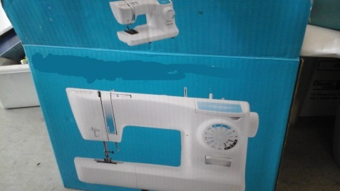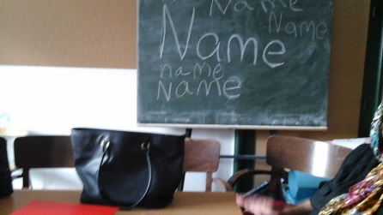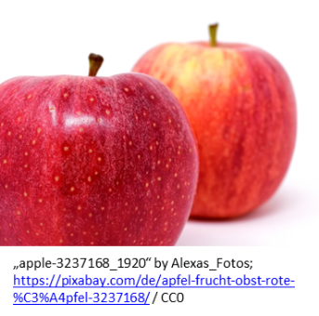

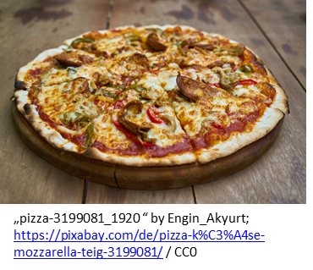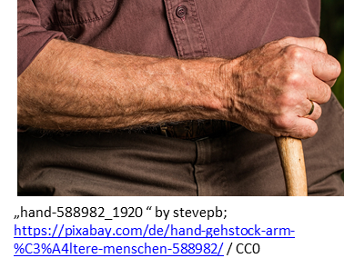

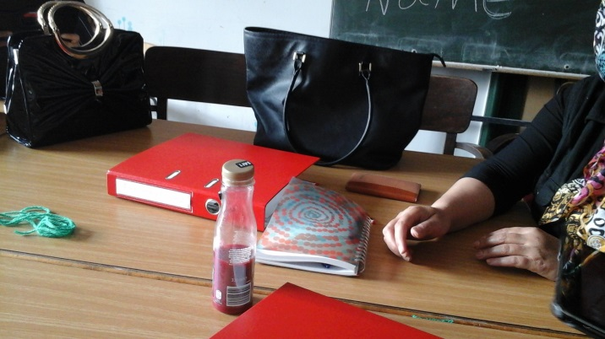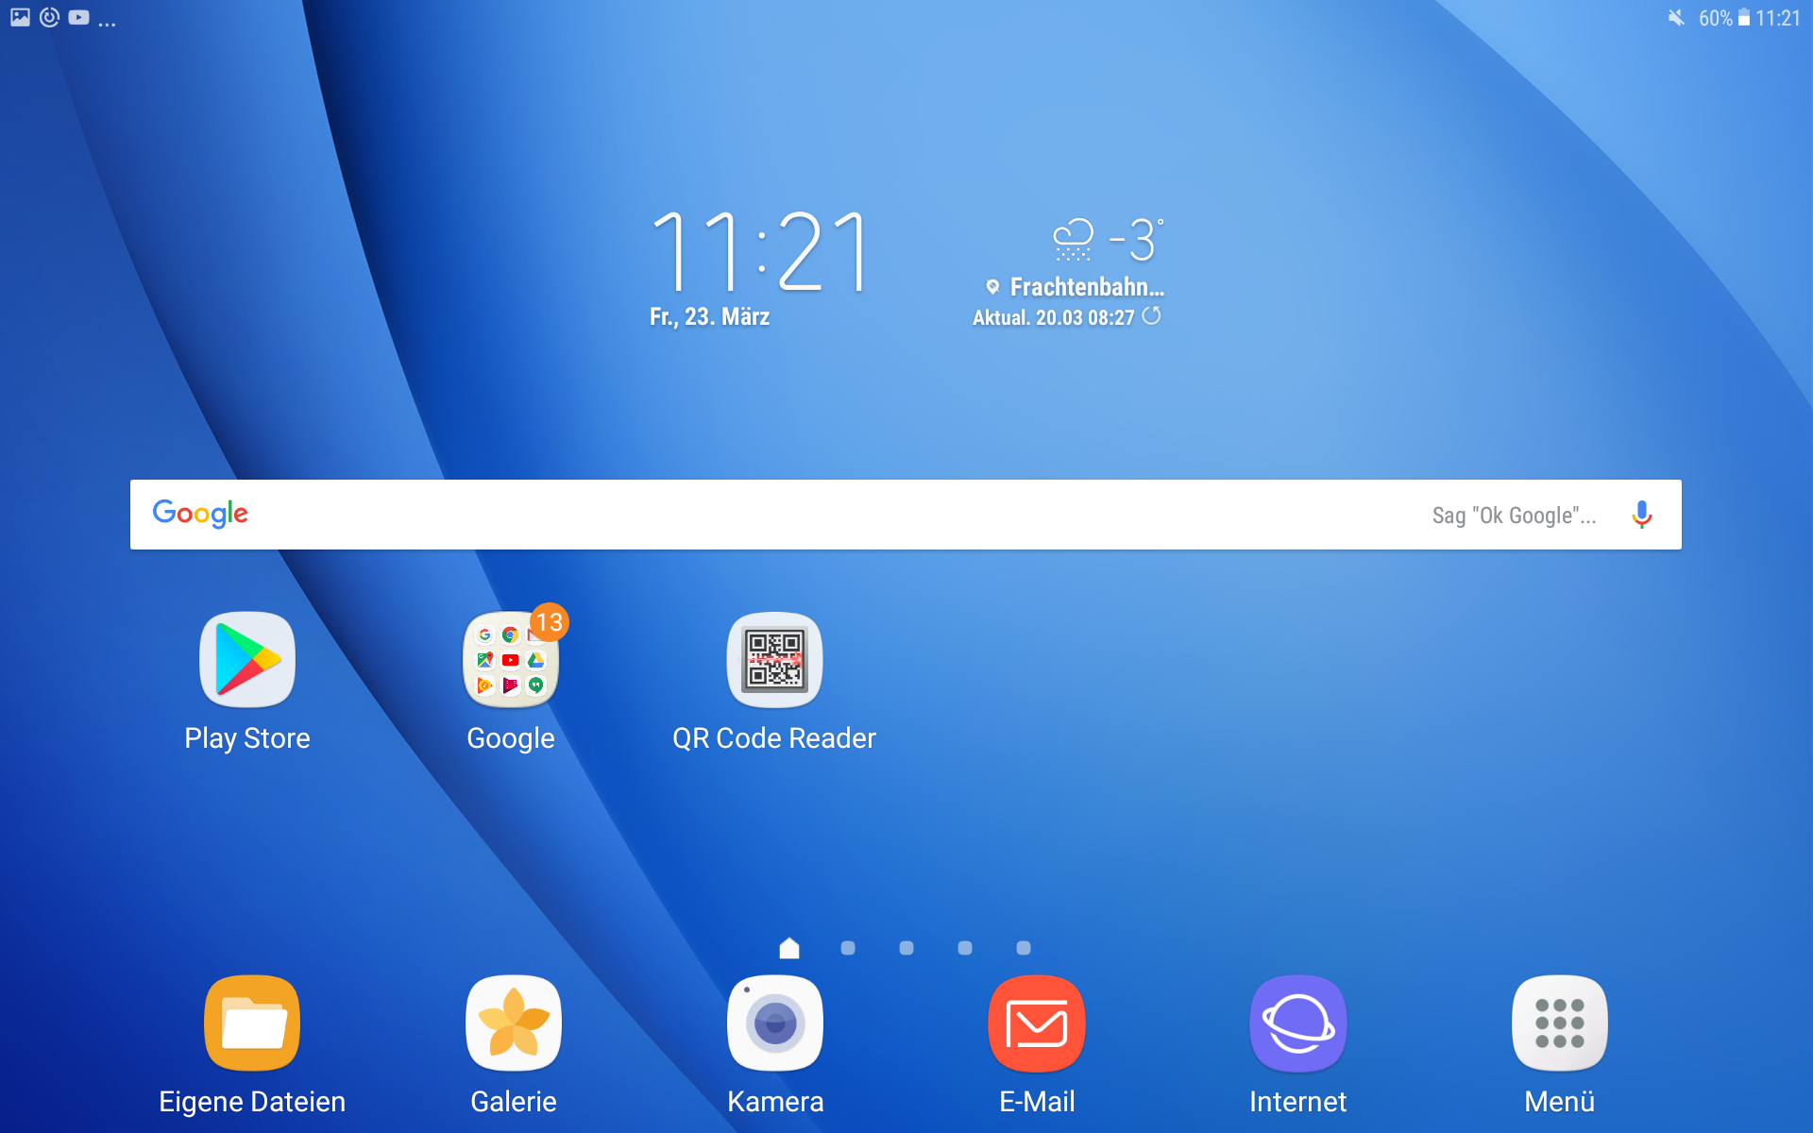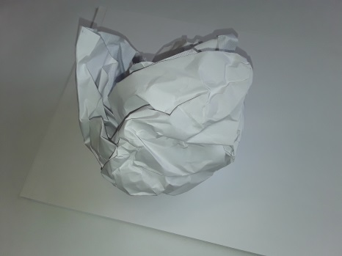

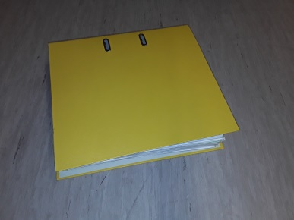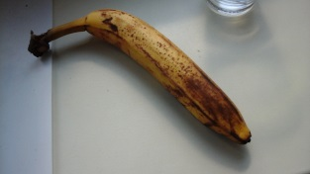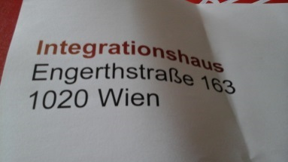

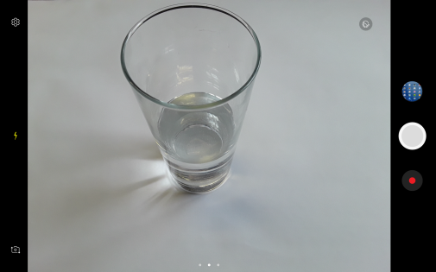

Ursula

Martin



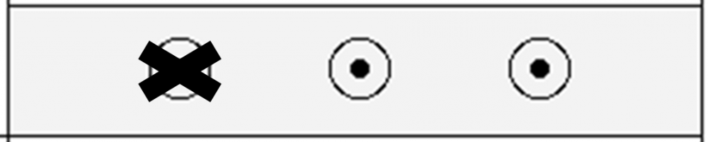



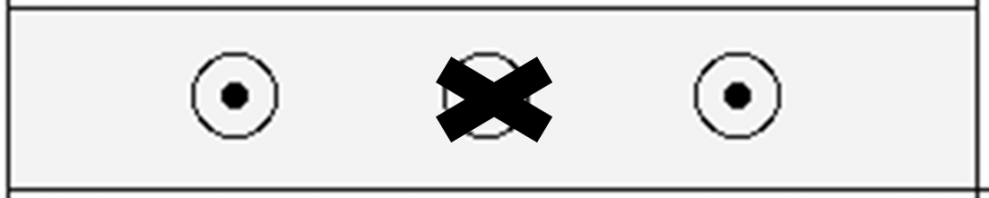



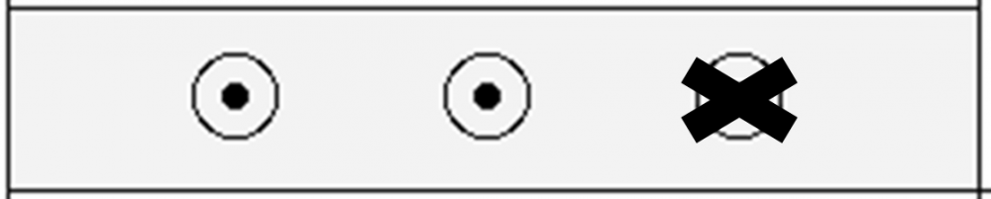





<https://learningapps.org/watch?v=pumbi25wj16>