Name:______________________ Datum: ____________
Der Computer
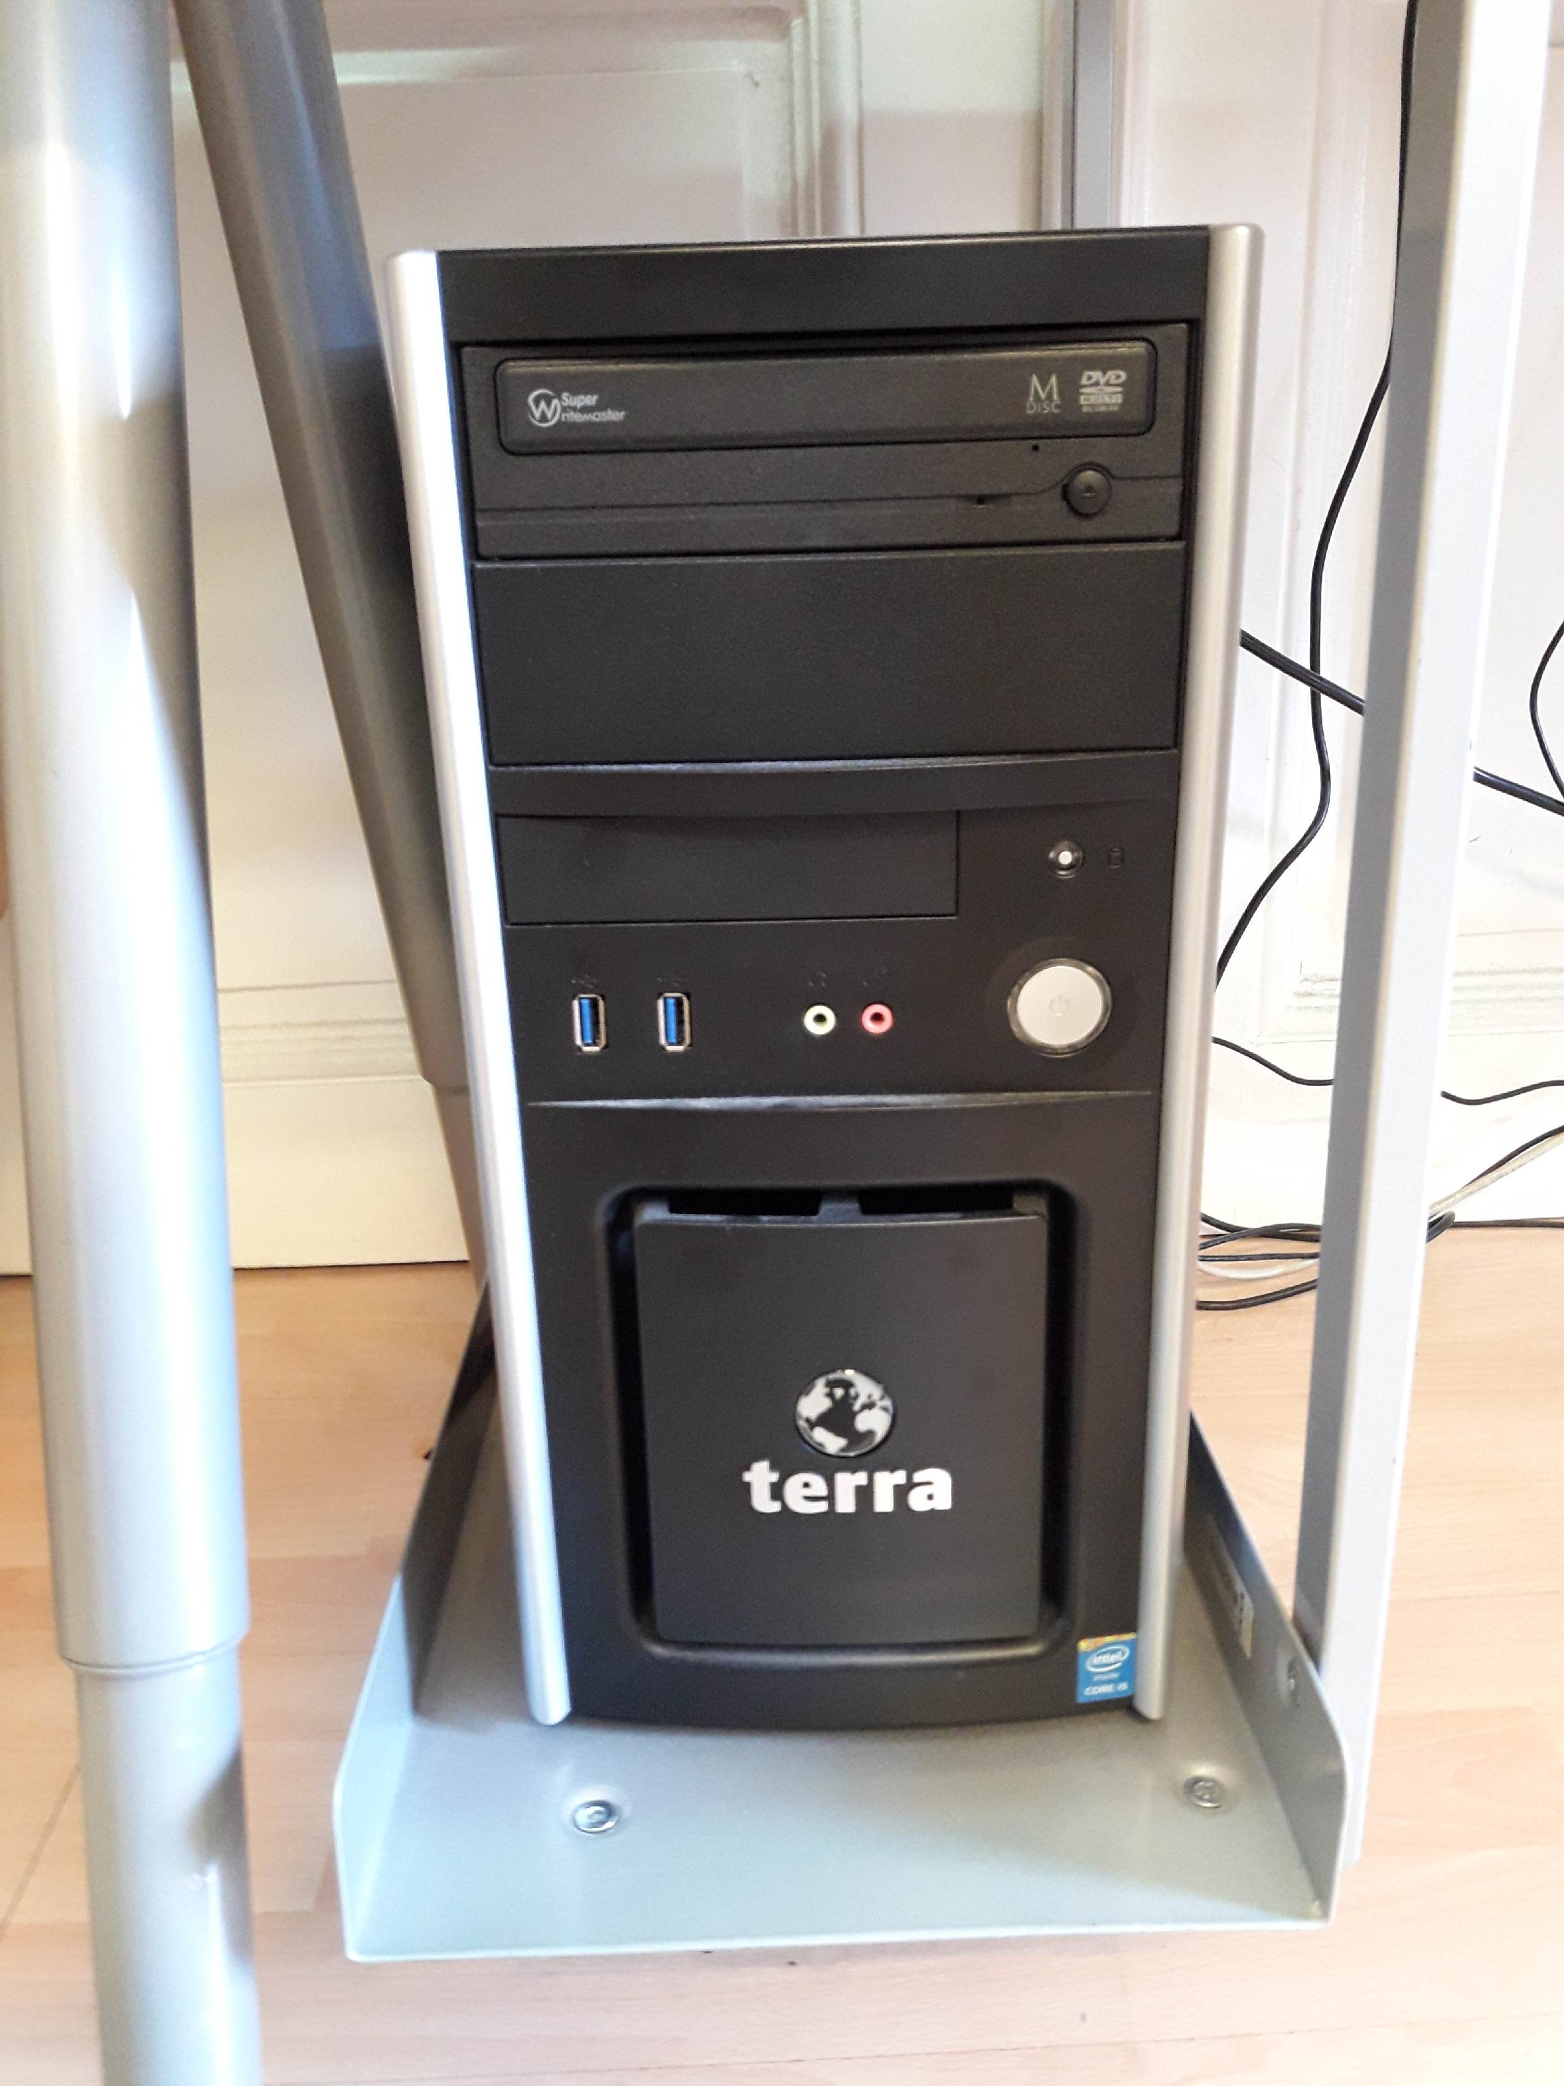

Foto Danaida

